**INTERNSHIP II -REPORT**

***Submitted by***

**AKASH S A (22BTAD004)**

in partial fulfilment for the award of the degree of

**BACHELOR OF TECHNOLOGY**

**IN**

**ARTIFICIAL INTELLIGENCE AND DATA SCIENCE**



**Karpagam Academy of Higher Education**

**COIMBATORE – 641021**

**TAMILNADU INDIA**

**MARCH 2025**

**DEPARTMENT OF ARTIFICIAL INTELLIGENCE AND DATA SCIENCE**

This is to certify that

**INTERNSHIP II REPORT**

is the Bonafide report by

**AKASH S A (22BTAD004)**

of B.Tech Artificial Intelligence and data science during the year 2024-2025

**Dr B. Arunkumar**

Faculty Co-Ordinator Head of the Department

**TABLE OF CONTENTS**

|  |  |  |
| --- | --- | --- |
| **S.No** | **Particulars** | **Page No** |
| 1 | Acknowledgement | 4 |
| 2 | Executive Summary | 5 |
| 3 | Completion Certificate | 6 |
| 4 | About the Organization | 7 |
| 5 | Objective | 8 |
| 6 | Nature of Work and Task Assigned | 9 |
| 7 | Opportunities | 10 |
| 8 | Overall learning Outcomes | 11 |
| 9 | Challenges Faced | 13 |
| 10 | Conclusion | 14 |

# ACKNOWLEDGEMENT

Any organized and systematic work calls for the co-operation and co-ordination of a team of people. My internship program is no exception to this. Hence, these pages find the space for thanking all those who have directly and indirectly contributed to the completion of this work in a successful manner.

I express my gratitude to **Dr.R.Vasanthakumar, B.E. (Hons)., D.Sc.,** President, Karpagam Charity trust, for his encouragement and support in this internship program.

I sincerely thank **Shri.K.Murugaiah, B.E,** CEO, Karpagam Educational Institutions, for his constant support and enduring encouragement for the successful completion of the internship program

I sincerely thank **Dr. B.Venkatachalapathy,**Vice Chancellor of Karpagam Academy of Higher Education, for his encouragement and support in this internship program.

I sincerely thank **Dr.S.Ravi,** Registrar of Karpagam Academy of Higher Education, for his encouragement and support in this internship program.

My special thanks to **Dr.P.Palanivelu,** Controller of Examinations, Karpagam Academy of Higher Education, for his timely help for the progress of this work for his valuable suggestion and timely help.

I express my heartfelt thanks to **Dr.A.Amudha,** Dean, Faculty of Engineering, Karpagam Academy of Higher Education, for his encouragement and support in this internship program.

I express my heartfelt thanks to **Dr.B.Arunkumar,** Professor and Head, Department of Artificial Intelligence and Data Science, Faculty of Engineering, Karpagam Academy of Higher Education, for his encouragement and valuable guidance in this internship program.

I also express my thanks to my faculty team, my parents, my friends, wellwishers for their encouragement and best wishes in the successful completion of this internship program.

# EXECUTIVE SUMMARY

The 15- days Internship Program at PRIME SOLUTIONS is a vital part of the 2-year B.Tech Course. Since majority of the students come without any prior work experience, the Internship adds worth to their CVs by giving each student immense learning. At PRIME SOLUTIONS, a student can bag an internship through various means since the Organization gives us ample opportunities to interact with industry experts.

Research has played a pivotal role as a part of this internship program and I have been able to enhance the same through this opportunity. I have been able to understand the body of work in a professional legal sphere with the help of this internship program. Programming using python could be understood and interpreted in a better way due to this opportunity.

**COMPLETIONCERTIFICATE**

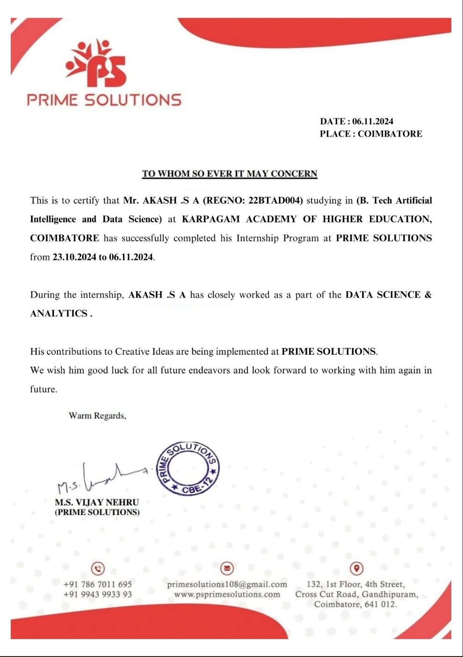

**ABOUT THE ORGANIZATION**

PRIME SOLUTIONS is a Software Training and Project based company that provides reliable and efficient technology products and services across multiple frameworks and business functions in COIMBATORE, we are committed to delivering cost effective, client specific solutions.

Founded in 2013, PRIME SOLUTIONS has been a successful provider in the areas of Software Training such as HTML, CSS, JAVASCRIPT, Nodejs, React js, Angular js, PHP, WordPress, .NET, Full Stack Development, JAVA, J2EE, SOFTWARE TESTING-AUTOMATION, ANDROID, PYTHON.

Prime Solutions also providing Hardware Trainings in the areas of: EMBEDDED, INTERNET OF THINGS(IoT), POWER ELECTRONICS, POWER SYSTEM, MACHINE LEARNING, ARTIFICIAL INTELLIGENCE, VLSI, MATLAB.

# OBJECTIVES

1. Develop expertise in data preprocessing techniques, such as data cleaning, transformation, and feature engineering.
2. Enhance proficiency in tools like Tableau, Power BI, or Matplotlib for data visualization and storytelling.
3. Strengthen coding skills in Python, R, or SQL for efficient data
4. Work on real-world projects involving data wrangling, predictive modelling, and optimization of solutions.
5. Analyse large datasets to uncover trends, patterns, and actionable insights for business decision-making.
6. Explore advanced techniques such as machine learning, natural language processing (NLP), or time series analysis.
7. Stay updated with emerging trends and tools in the field by attending webinars and online workshops.
8. Build a portfolio showcasing analytical and problem-solving skills through diverse projects.
9. Develop critical thinking by addressing and solving ambiguous, complex data challenges.

## NATURE OF WORK AND TASK ASSIGNED

## Prime Solutions, a prominent player in software IT solutions, is actively engaged in various projects and endeavours focused on harnessing data science technology to empower businesses in making data-driven decisions, attaining objectives, and maintaining competitiveness. The following tasks have been designated in this internship program:

## Learning Data Science Fundamentals: Gaining a solid foundation in data science, including data preprocessing, statistical analysis, and understanding machine learning algorithms.

## Data Collection and Integration: Writing SQL queries to extract and manage data from various databases, along with integrating diverse datasets for comprehensive analysis.

## Analytical Projects: Conducting exploratory data analysis (EDA) to uncover trends, patterns, and actionable insights, and building predictive models to solve real-world problems.

## Testing and Validation: Involved in model testing and validation to assess performance, accuracy, and reliability of predictive or descriptive analytics solutions. This includes preparing detailed documentation of findings and methodologies.

## Visualization and Communication: Creating intuitive visualizations and dashboards using tools like Tableau, Power BI, or Matplotlib to effectively communicate analytical insights to stakeholders Data

## OPPORTUNITIES

A wide range of opportunities for professional growth, career advancement, and skill development to help in careers and achieve the goals. Some of which include

1. **Data Scientist:** Analyse and interpret complex data to provide actionable insights and help companies make data-driven decisions.
2. **Machine Learning Engineer:** Design and deploy machine learning models and algorithms to create intelligent systems.
3. **Data Analyst:** Focus on processing and visualizing data to identify trends and deliver reports to stakeholders.
4. **Business Intelligence Analyst:** Create dashboards and reports using tools like Tableau and Power BI to support business strategies.
5. **Big Data Engineer:** Build, maintain, and optimize large-scale data processing systems and architectures.
6. **Data Engineer:** Develop and maintain data pipelines, ensuring data accessibility and quality for analytical teams.
7. **AI Research Scientist:** Conduct research on artificial intelligence and contribute to the development of cutting-edge technologies.
8. **Data Visualization Specialist:** Design visual storytelling tools to represent complex datasets in a comprehensible way.

## OVERALL LEARNING OUTCOMES

Engaging in internship experiences within a company, from technical training sessions to development initiatives, and leveraging resources and opportunities for personal and professional growth, contributes to enhancing skills, broadening knowledge, and keeping abreast of the latest trends and technologies in data science and analytics. The learning outcomes encompass:

1. Gain expertise in **data collection, cleaning, and preprocessing** for accurate analysis.
2. Develop **programming skills** in Python, R, and SQL for data manipulation and analysis.
3. Learn **data visualization techniques** using Matplotlib, Seaborn, Tableau, or Power BI.
4. Apply **statistical methods** such as probability, hypothesis testing, and regression analysis.

1. Understand and implement **machine learning models** using Scikit-learn.
2. Improve **critical thinking and problem-solving** skills by analysing complex datasets.
3. Gain **business domain knowledge** to apply data insights in industries like finance, healthcare, and retail.
4. Develop **collaboration and teamwork** skills by working on real-world projects with cross-functional teams.

## CHALLENGES FACED

Some of the challenges that are faced during the internship program are:

1. **Data Cleaning Complexity:** Handling large datasets often involved dealing with missing values, inconsistencies, and outliers, making data preprocessing a time-consuming task.
2. **Debugging Errors:** Identifying and fixing errors in data pipelines, SQL queries, and machine learning models was challenging, especially when working with unfamiliar datasets.
3. **Handling Big Data:** Processing large volumes of data required efficient techniques and optimization strategies, as working with limited computing resources sometimes led to slow performance.
4. **Understanding Business Logic:** Aligning data analysis with business objectives and understanding domain-specific requirements took time and effort.

1. **Interpreting Results:** Extracting meaningful insights from statistical analyses and machine learning models was sometimes complex, especially when dealing with ambiguous or conflicting patterns.
2. **Data Visualization Difficulties:** Choosing the right type of visualization and effectively representing data insights for non-technical stakeholders required practice and refinement.
3. **Learning Curve for New Tools:** Adapting to new software, programming languages, or frameworks (e.g., Tableau, Power BI, Hadoop) required extra effort and time.

# CONCLUSION

My internship has been a transformative learning experience, providing me with hands-on exposure to real-world data challenges and industry best practices. Throughout this journey, I have developed strong technical skills in data analysis, programming, and problem-solving while also enhancing my ability to work collaboratively in a professional setting.

Despite facing challenges such as debugging errors, handling large datasets, and adapting to new tools, these experiences have strengthened my resilience and analytical thinking. The opportunity to work on real projects has deepened my understanding of business applications, data-driven decision-making, and effective communication of insights.

Overall, this internship has not only expanded my technical expertise but also prepared me for future roles in data science and analytics. I am grateful for the knowledge gained, the mentorship received, and the skills honed, all of which will serve as a strong foundation for my professional growth.